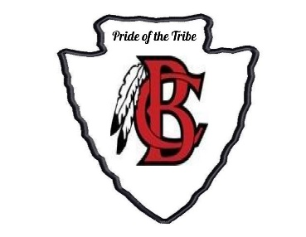
Bryan County High School Band Booster Club
Gail Morris, President
Katie Robenolt, Vice President
Tonya DuBose, Secretary
Kathy Greenwell, Treasurer

Pride of the Tribe Marching Band 1234 Camellia Drive, Pembroke, GA 31321
Phone: 912-626-5060
Booster Meeting Minutes from March 12, 2019
- Call to order
Gail Morris called to order the meeting of the BCHS Band Booster at 6:44 on March 12, 2019 at the BCHS band room.
- Roll call
Tonya DuBose recorded all in attendance. The following persons were present: Gail Morris, Kathy Greenwell, Patrick Forrester, Donna Arnold, Kevin Greenwell, Melody Nelson, Jason Blair and Tonya DuBose
- Approval of Minutes
  - February 5, 2019 as posted on bchsband.com
Motion: Second: Action:
- Old Business
- Financial Statement February
- Total: Income = $6,999 Expenses = $5,106.22
- Balance as of February 28, 2019
  - $5,242.18
- New Business
- Fundraisers
    - Scott’s Masterpiece a profit of $2064 Correction from February report
    - 1st Annual BCH Band Boosters Sporting Clays Event 2/16/19
      - Income = $2,200 Expenses = $1,349
      - Total Profit $1,500
Upcoming Events
Jazz Band Began on March 13, 2019
Jazz Dinner Fundraiser
May 4, 2019 Time TBA Price TBA

Officer Nomination
Rob Robenolt – for Vice President

Directors Report
Jazz Band
Starts practice March 12 @ 3:30 – 4:30
5th Grade Recruitment trip
Black Creek School Museum

Office Elections
Officer Voting April

Band Camp
Rookie Camp Dates
May 23, 24
Full Camp
July 24 – July 31 (Pool party)
Uniform fitting (tabled)

New Fundraisers
Gaming package
Boston Butts
(tabled) Golf Tournament Jason Blair point

Booster Remind Code
@btreas

- Next Meeting
Scheduled Tuesday, April 2nd in the band room at 6:30 pm
Gail Morris adjourned the meeting at 7:04 pm
Minutes submitted by: Tonya DuBose

