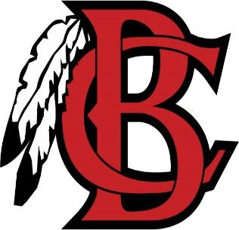
Bryan County High Band Booster
Jake Blair, President
Tori Blair, Vice President
Kellie Coe, Secretary
Kathy Greenwell, Treasurer

Pride of the Tribe Marching Band 1234 Camellia Drive, Pembroke, GA 31321
Phone: 912-626-5060

Booster Meeting Minutes from November 1, 2022
I. Call to order
Jake Blair called to order the meeting of the BCHS Band Booster at 6:35 on November 1, 2022 at the BCHS band room.
II. Roll call: Attendance recorded by Kellie Coe recorded all in attendance. The following persons were present: Raven Pridgen, Jen Parker, Challise Bryan, Laura McDonald, Kenny Mc Donald, Janet Sosa, Nelson Sosa, Kathie Steinberger, Sherry Arthur, Jake Blair, Tori Blair, Kellie Coe, Kathy Greenwell, Avery Gallups, Bailey Uselton
III. Minutes for Last Meeting were posted to the website for review.
IV. Old Business
a. Checkbook balance: $8,703.09 (Spirit Store deposit not made, Jackets not paid for until all are in)
b. Spirit Store last home game: $702.00
c. Fall Festival and Concert
i. Costs: $361.31
ii. Profit: $1446.69
iii. School Account: $631.00 (for Winterguard)
d. Qualification Amendment: Discussion was had on the amendment of section 2.01
Qualification.
i. Motion to adopt the new amendment worded as follows: “Section 2.01. Qualification. Any adult, over age 18, that is interested in the aims and objectives of our purpose may be a voting member of the organization. The Band Director(s) and Band Staff shall be non- voting, advisory members of the organization.”
ii. Motion made by: Sherry Arthur
iii. Motion seconded by: Kathie Steinberger
iv. Vote was unanimous
v. Amendment passed
V. New Business
a. Christmas Parade – Dec 10th
i. We will have a booth at the parade – set up will be 9-11, booth will be open from 11:00 to 4:30. There will be a sign up sheet on the website for 2 hour shifts. We will be selling light up novelties and stocking stuffers, t-shirts, baked goods and possibly BBQ sandwiches
ii. Call time for students is 4:00
iii. It was suggested we that we can pass out flyers with the Christmas Concert date
b. Christmas Concert
i. December 13th @ 6:30
c. Uniforms: Mr. Gallups has been in contact with several vendors. We will need to order jackets, new plumes and covers for the existing shakos. If we can pay 1/3 down, we can start designing, getting samples and secure our order.

VI. Next Meeting is scheduled Tuesday, December 6, 2022 in the band room at 6:30
VII. Meeting Adjourned by Jake Blair at 7:41

